Extending linear regression to nonlinear problems
How to adapt linear regression to nonlinear patters regularization

Ex
Predicting house prices
If price increases linearly with size…works well – LR works
But what happens if price increases exponentially with location or dips for very old houses… this kind of behavior is non linear
To handle non linear data – apply regularization

General linear regression equ
Y=B0+B1x1+B2x2 +…..+Bnxn+e

Ex
Temperature vs ice cream sales – it rises, and then suddenly drops…in such cases linear regression may not be applied but we do feature engineering – transform the features

Solving linear regression with Matrices
Normal equ for linear regression via matrix algebra
B (beta) = (X^T.X)^-1.X^T.y
X is design matrix containing the input features (each row is a data point, each column is a feature)
y is the target vector (the outputs we’re trying to predict)
X^T is the transpose of X
(X^T.X)^-1 is the inverse of the product of X^T and X
B (beta) – vector of coefficients

Assumptions of Linear Regression
LR assumes
- Linearity
- Independence of errors
- Normality of residuals
- Homoscedasticity

Regularization controlling complexity
When we add many inputs / add polynomial features – the model can overfit – it memorizes noise instead of learning patterns
Regularization adds a penalty to large coefficients,

Two regularization techniques
- Ridge
- Lasso

Ex
Lets say if you have 20 features, Lasso might keep only 5. Ridge keeps all but shrinks them.

Ridge regression Loss function
Equation –
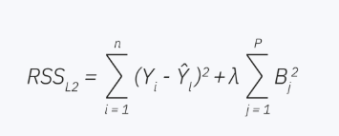
Yi is the actual value for the ith data point
is the predicted value
Bj are model coefficients
is the regularization strength
n is the no.of data points
p is no.of features

this term 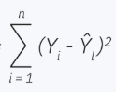 is the ordinary least squares – it measures how well the model fits the data
other term
sigma Bj^2 is the penalty – it discourages large coefficients – that helps prevent overfitting

Lasso Regression loss function
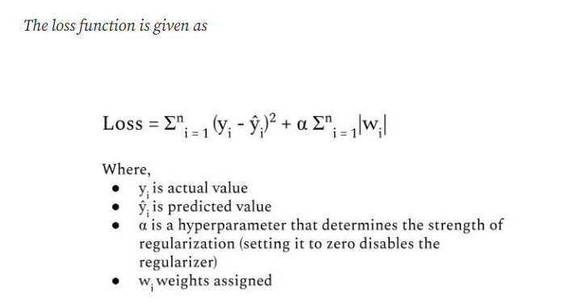

Estimating coefficients in simple linear regression
If want to build linear regression model, we need to find best values for the intercept and slope
By minimizing RSS – residuals sum of squares – total squared difference between actual and predicted values

RSS = 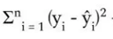

= B0-B1xi
(yi-B0-B1xi)

RSS is cost function , smaller RSS, better the model fits the data

Gradient descent – iterative optimization
We start with initial guesses for B0 and B1, and update them using the slope of the cost function

Like
Start with B0 = 0, B1=0
After each iteration, adjust them slightly to reduce RSS
Stop when changes become very small (convergence)

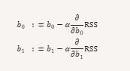

Here alpha is the learning rate – a positive number that control the step sie
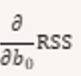 and 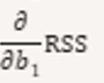 are the partial derivatives of the cost function with respect to each parameter

Start with initial guesses B0 and B1 (often zero)
At each step, compute how much RSS changes w.r.t to each parameter
Move the parameters in the direction that reduces RSS
Repeat until parameters converge (stop changing significantly)

Matrix representation for Simple linear regression
- Simplicity
- Scalability
- Matrix form going to allow to write regression problem in a compact form
- Performance
  - Python’s Numpy makes handling large matrices easy and memory efficient

Regression equ
Yi = B0+B1xi+ E1

If you have n observations…n such equations

Y=XB+e

Y vector of responses (n x1)
X design matrix (n x 2)
- First column is all 1’s ( Intercept )
- Second column is predictor values (xi)
B (beta) vector coeffecients (B0, B1…)
e error/residuals vector

matrix notation of finding coefficients using equ
B (beta) = (X^T.X)^-1.XT.Y
- X^T.X capture the relationships among predictors
- XT.Y captures relationships between predictors and target
- Multiplying them and taking the inverse give us best fit coefficients

It can be either simple linear case or multiple linear Reg …the same formula works
SLR X has two columns of 1’s ( intercept) and one column for x
MLR X becomes as nx(P+1) matrix ( 1 intercept + p predictors), B(beta) becomes a (p+1) x 1 vector

SLR with 3 observations
Dataset (n=3)
x (Predictor) | y (response)
1 | 2
2 | 3
3 | 5

Fit to the regression line y = B0+B1.x

Matrix form
- Y = X.B + e

Y (n x 1 vector)

Y = [ 2
3
5]

X = [ 1 1
1 2
1 3]

From above – 1stt column is for intercept, second column is the predictor values

B (beta) vector

B = [ B0
B1]

Apply the matrix equation
B (beta) = (X^T.X)^-1.XT.Y

Step-1
Transpose of X = X^T = [ 1 1 1
1 2 3]

Step-2
Multiply X^T.X

[ 1 1 1 [1 1
1 2 3] . 1 2
- 3]
= [ 3 6
6 14]

Step-3
Multiply X^T . Y

[ 1 1 1 [ 2
1 2 3] . 3
5]

= [ 10
23]

Step-4

(X^T.X)^-1 =

[2.33 -1
-1 0.50]

Step-5

Multiply to get B

B (beta) = (X^T.X)^-1.XT.Y

=
[2.33 -1.0 [10
-1.0 0.50] . 23]

Do the multiplication

[ (2.33) (10) + (-1)(23)
(-1_(10)+(0.5)(23) ]

= [ 0.3
1.5]

Final regression line - y bar = 0.3 + 1.5 x

B0 = 0.3
B1=1.5
- For every increase of 1 in x, the predicted y increases by about ~1.8

Assignment
Estimating coefficients in multiple linear regression
Ex
Predicting house prices using only size may miss other imp factors like location, age and no.of bedrooms

Equation –
yi = B0+B1xi,1+B2xi,2+……+Bnxi,k + ei

i = 1…..n observations
k= no.of predictors
B0 = intercept
B1,B2,….Bk = coefficients for each predictor
Ei = error term

Matrix representation / compact form
Y=XB + e
Y – vector of response
X - nx(k+1)
B – coefficients vector – ((k+1)x1)
E – error vector

n observation and k predictors – write matrix representation

X = [ 1 x1,1 x1,2 …………x1,k
1 x2,1 x2,2…………..x2,k
………
…….
1 xn,1 xn,2……………xn,k]

Rows = each observation
Columns = predictors (plus the intercept form)

Calculation of best estimates – ( to minimize the residuals sum of squares (RSS))

B (beta) = (X^T.X)^-1.XT.Y

Assignment
Observations | x1 | X2 | y
1 | 1 | 2 | 4
2 | 2 | 0 | 3
3 | 3 | 1 | 5

MLR y = B0 + B1x1 + B2x2

B (beta) = (X^T.X)^-1.XT.Y

Follow similar steps as above

